**Getting Started with Google Coral**

**Google Coral**

Front and back view of google coral

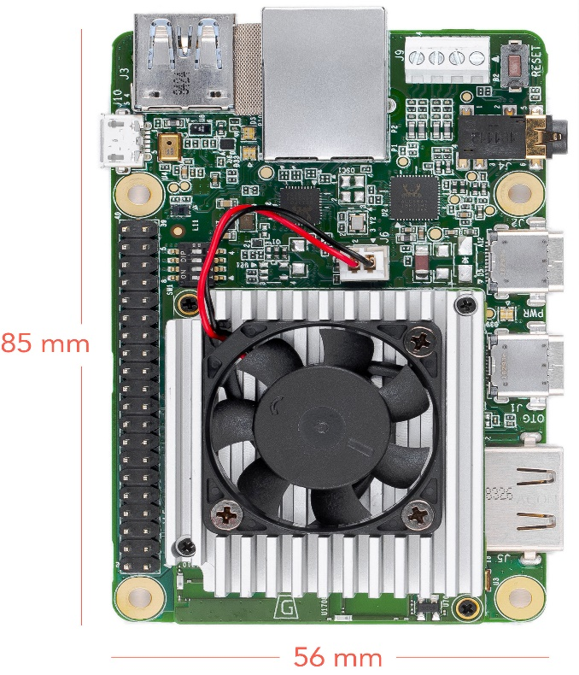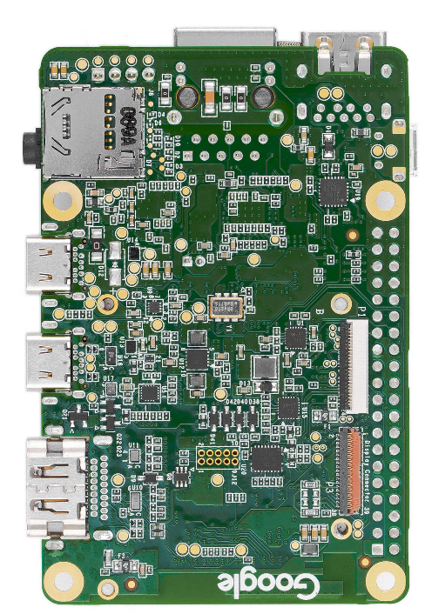

**Features**

* Edge TPU System-on-Module (SoM)
  + NXP i.MX 8M SoC (Quad-core Cortex-A53, plus Cortex-M4F)
  + Google Edge TPU ML accelerator coprocessor
  + Cryptographic coprocessor
  + Wi-Fi 2x2 MIMO (802.11b/g/n/ac 2.4/5GHz)
  + Bluetooth 4.1
  + 8GB eMMC
  + 1GB LPDDR4
* USB connections
  + USB Type-C power port (5V DC)
  + USB 3.0 Type-C OTG port
  + USB 3.0 Type-A host port
  + USB 2.0 Micro-B serial console port
* Audio connections
  + 3.5mm audio jack (CTIA compliant)
  + Digital PDM microphone (x2)
  + 2.54mm 4-pin terminal for stereo speakers
* Video connections
  + HDMI 2.0a (full size)
  + 39-pin FFC connector for MIPI DSI display (4-lane)
  + 24-pin FFC connector for MIPI CSI-2 camera (4-lane)
* MicroSD card slot
* Gigabit Ethernet port
* 40-pin GPIO expansion header
* Supports Mendel Linux (derivative of Debian)

**Baseboard Connections**

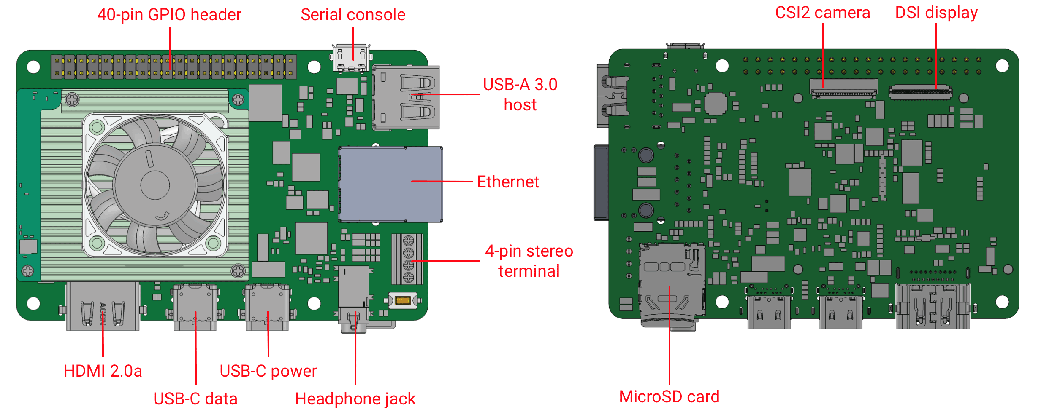

**Requirements**

**Note:** Do not power the board or connect any cables until instructed to do so.

Before you begin, collect the following hardware:

* Linux or Mac computer (referred to below as "host computer")
* USB-A to USB-microB cable (to connect your PC to the board's serial port)
* USB-A to USB-C cable (to connect your PC to the board's data port)
* 2 - 3A (5V) USB Type-C power supply (such as a phone charger)
* Ethernet cable or Wi-Fi connection

Steps –

1. Installing screen tool that will help us to view booting of mendel linux in ubuntu

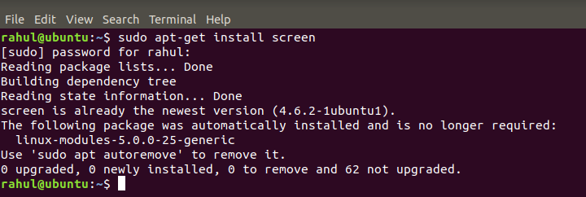

1. Installing fastboot to boot mendel linux in ubuntu

Visit below site to install fastboot tool

<https://developer.android.com/studio/releases/platform-tools#downloads>

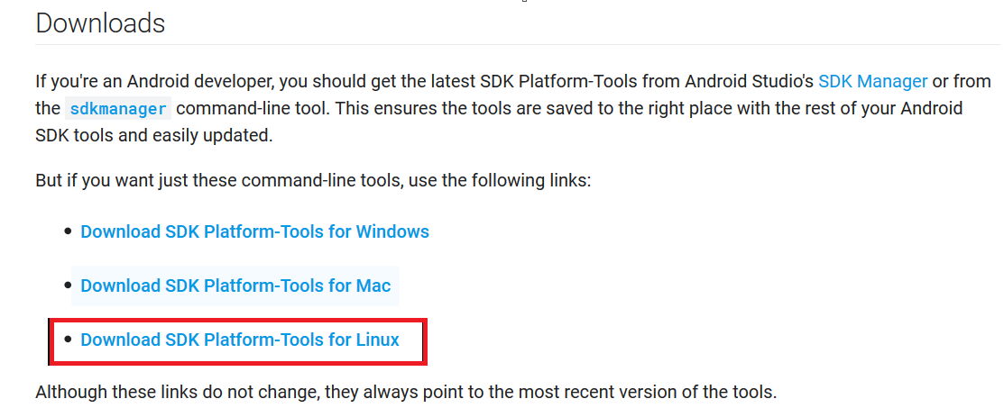

Create a directory

* 1. mkdir -p ~/.local/bin



* 1. Extract the downloaded fastboot tool and keep fastboot file and delete all rest files

sudo mv ~/Downloads/platform-tools/fastboot ~/.local/bin/



Now check fastboot version

It must print fastboot version 29.0.2-5738569 (as of now this is the latest fastboot version)



Incase, if you are seeing any different version. Please follow below steps

1. sudo apt-get install fastboot
2. Placed below file in your Downloads folder location



1. copy fastboot file to ‘/usr/lib/android-sdk/platform-tools/’ folder location

sudo cp /home/rahul/Downloads/fastboot usr/lib/android-sdk/platform-tools/



1. Verify fastboot placed or not in ‘/usr/lib/android-sdk/platform-tools/’ folder location

ls



1. Verify fastboot version

fastboot --version

It must print fastboot version 29.0.2-5738569 (as of now this is the latest fastboot version)



1. Downloading Mendel Development Tool (MDT)

MDT is a command line tool that helps you perform tasks with connected Mendel devices, such as this Dev Board. For example, MDT can list connected devices, install Debian packages on a device, open a shell with a device, and more.

Install MDT using pip as follows:

Incase pip is not installed in your system

<https://linuxize.com/post/how-to-install-pip-on-ubuntu-18.04/>

**pip3 install --user mendel-development-tool**

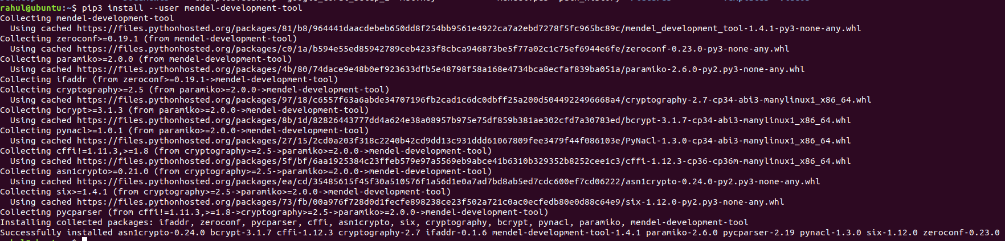

1. Flash the Board

The factory settings do not include a system image, only the U-Boot bootloader.

Before you begin the flashing procedure, verify the following:

* The board is completely unplugged (not powered and not connected to your computer).
* The boot mode switches are set to eMMC mode (see figure 1):

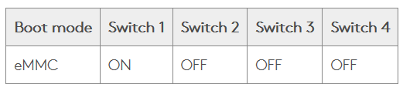

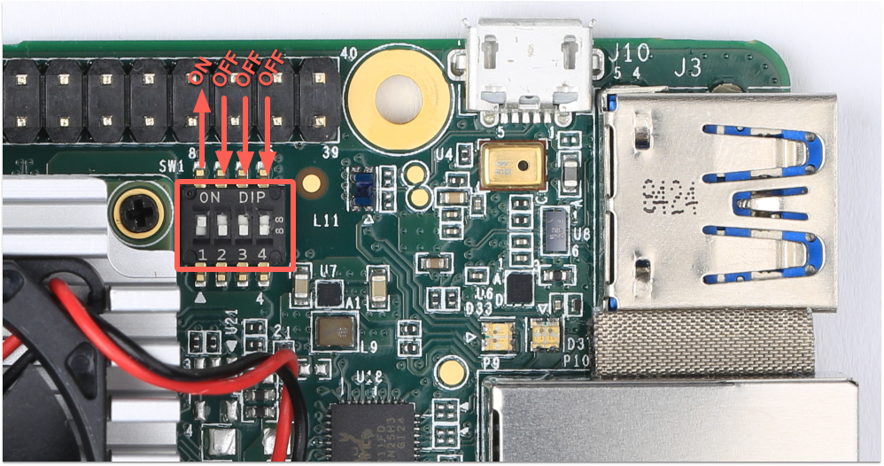

Please see above image to know which switch to own. Please do it carefully 😊

Now flash the board as follows:

1. **Install the udev rule or driver on your host computer.**

This is required to communicate with the Dev Board over the serial console.

* + **On Linux:**

Run the following commands to add the required udev rule:

sudo sh -c "echo 'SUBSYSTEM==\"usb\", ATTR{idVendor}==\"0525\", MODE=\"0664\", \GROUP=\"plugdev\", TAG+=\"uaccess\"' >> /etc/udev/rules.d/65-edgetpu-board.rules"

sudo udevadm control --reload-rules && udevadm trigger

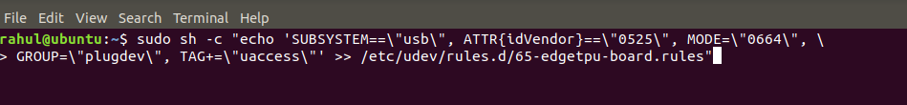

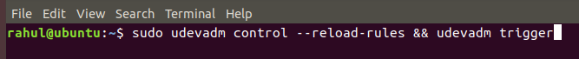

1. **Connect to the serial console.**

Note - In VM player whenever your are connecting any cables prompt window must come otherwise it will not detect any devices

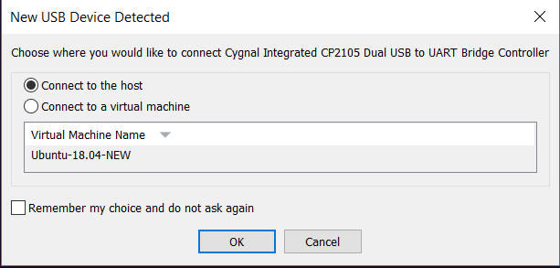

Use your USB-microB cable to connect your host computer to the serial console port on the board (see figure 2). The orange and green LEDs on the board should illuminate.

**Note:** The board should not be powered on yet.

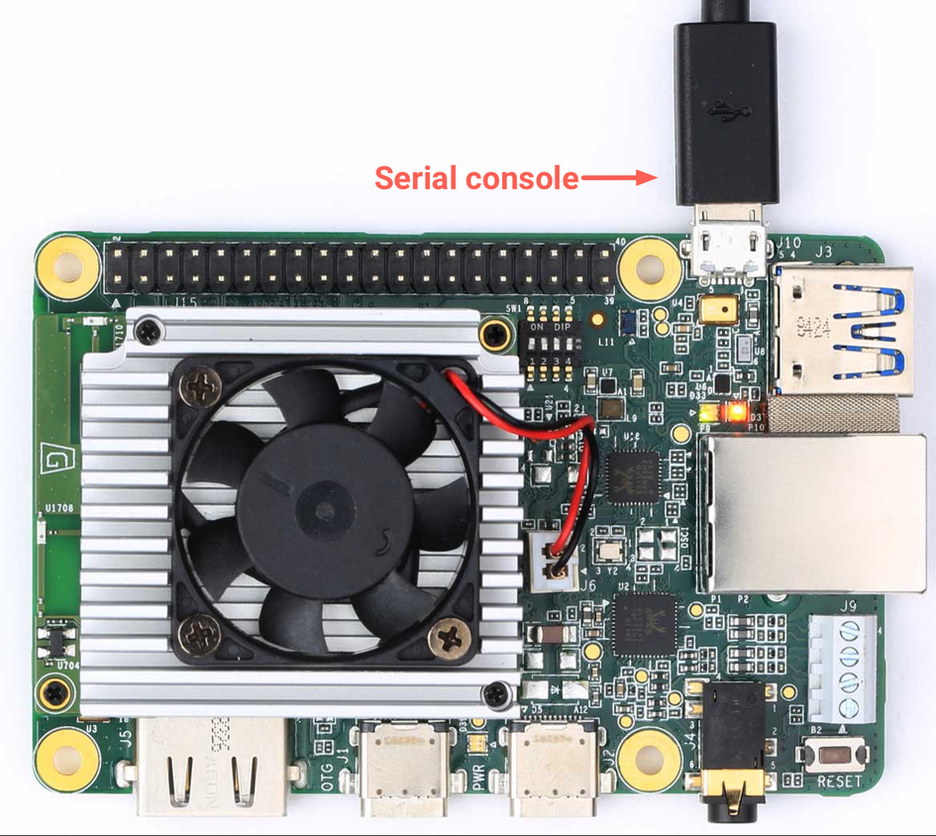

Now open a terminal on your host computer and start the serial console as follows:

Open a terminal(1) to run all below command

* **On Linux:**

Determine the device filename for the serial connection by running this command on your Linux computer:



You should see two results such as this:



Then use the name of the first filename listed as a cp210x converter to open the serial console connection (this example uses ttyUSB0 as shown from above):



The prompt should disappear and your terminal should become completely blank. That's expected, because you've established a connection but the board is not turned on yet.

If you see [screen is terminating]

Run command with sudo user

**sudo screen /dev/ttyUSB0 115200**

1. **Power the board.**

Plug in your 2 - 3A power cable to the USB-C port labeled "PWR" (see figure 3).

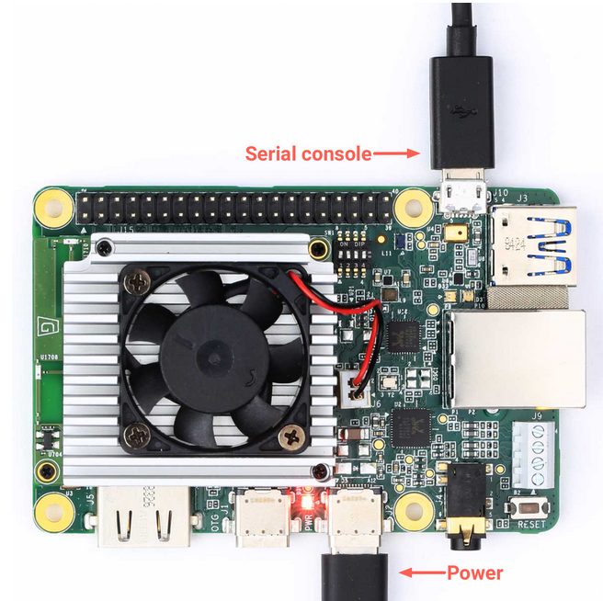

**Caution:** Do not attempt to power the board by connecting it to your computer.

Red light will blow and fan will start once you plug in power cable

Your serial console (the screen terminal) should arrive at the u-boot prompt. You should see a "Welcome" message that tells you to visit g.co/coral/setup, which brings you to this page. So you're all good; you can continue.

1. **Start fastboot**

In your serial console's u-boot prompt, execute the following:

fastboot 0



The cursor should simply move to the next line. Fastboot is now waiting for the host to begin flashing a system image.

You will see below screen once you plugin power cable

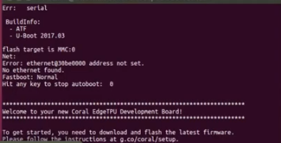

1. **Connect to fastboot over USB.**

Use your USB-C cable to connect your host computer to the USB-C data port labeled "OTG" on the Dev Board. (This is the connection used to flash the system image.)

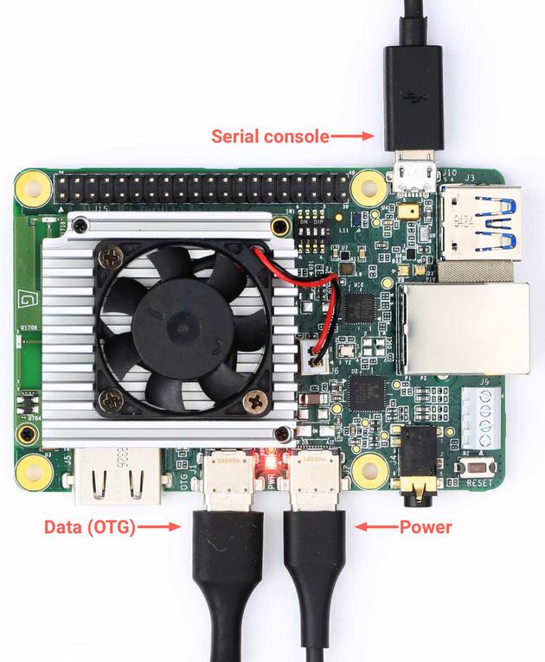

Now **open a new terminal** on your host computer (do not use the screen terminal) and execute the following command:

fastboot devices



You should see a line printed like this:



Note – If you are not seeing any fastboot devices. Please check below ways to fix issue

* + 1. Please try with another type C cable as For me it worked with 3rd type C cable
    2. If you don't see anything printed, verify the board is in fastboot mode (see step 4), and be sure you have the latest version of fastboot

1. **Download and flash the system image.**

From the same terminal (where you ran fastboot), execute the following:

cd ~/Downloads

curl -O <https://dl.google.com/coral/mendel/enterprise/mendel->enterprise-chef-13.zip

unzip mendel-enterprise-chef-13.zip \

&& cd mendel-enterprise-chef-13

bash flash.sh

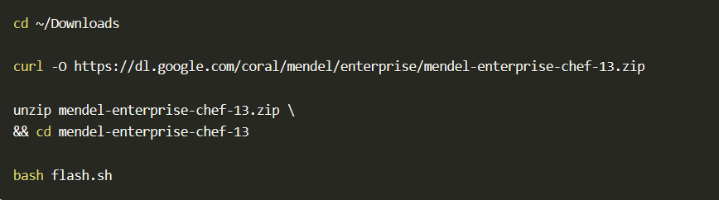

This starts the flashing process and you'll see various output.

In Fastboot 0 terminal

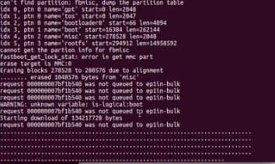

In bash flash.sh terminal

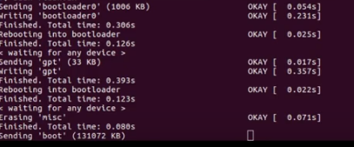

Once booting is completed you will see below screen

In bash flash.sh terminal

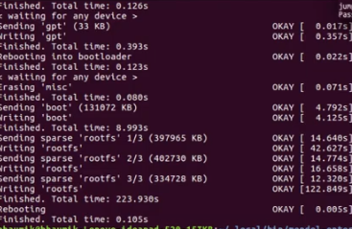

In Fastboot 0 terminal

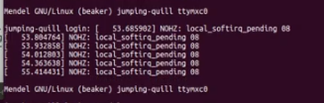

1. **Log in.**

Switch back to the serial console to observe the flashing progress. It takes about 5 minutes to complete. When it's done, the system reboots and the console prompt you to login. (The login prompt might be obscured by some logs, so press Enter when you notice the logging has stopped.)

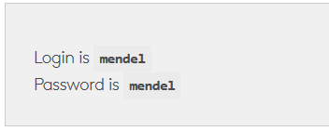

Your screen will look like below once you login

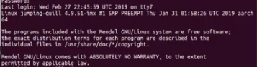

You should now be in the board's terminal.

**Note:** Your board's hostname is randomly generated the first time it boots from a new flashing. We do this to ensure that each device within a local fleet is likely to have a unique name. Of course, you can change this name using standard Linux hostname tooling (such as hostname).